2D Sobol Stochastic Image Multiplication
Implementation Plan — C++ / OpenCV / AVX2

1. Project Definition
The project will implement and evaluate RGB image multiplication using stochastic computing with a 2D Sobol low-discrepancy sequence. The primary comparison is between conventional image multiplication and a Sobol-based stochastic multiplier whose core multiplication operation is a bitwise AND.
The new project resource expands the original idea into a vectorized software architecture: RGB normalization, 2D Sobol stochastic number generation, 256-bit AVX2 packing using __m256i, bitwise AND kernels, circular bit rotation for de-correlation, population-count reconstruction, and Python-based image-quality analysis.
The original project notes provide the 2D Sobol stochastic-generator concept, 16-bit representation, and the 0.75 × 0.50 example. The 2024 IEEE paper provides the stochastic-computing basis, especially unipolar encoding, the need for appropriate correlation/independence, and the use of low-discrepancy sequences.

2. Core Algorithm
For normalized values pA and pB in [0,1], generate 2D Sobol points:
(x0,y0), (x1,y1), ..., (xN-1,yN-1)
Generate the stochastic streams:
A[k] = 1 if xk < pA, otherwise 0
B[k] = 1 if yk < pB, otherwise 0
Perform:
C[k] = A[k] AND B[k]
Decode:
pC ≈ popcount(C) / N
Geometrically, the AND output is 1 when both Sobol coordinates lie below their respective thresholds. The target region has area pA × pB, so the fraction of output ones estimates the product.

3. Example: 0.75 × 0.50
A = 0.75
B = 0.50
Expected product = 0.375
For every Sobol point:
A[k] = 1 when xk < 0.75
B[k] = 1 when yk < 0.50
Then A[k] AND B[k] produces the stochastic product stream.
After N points:
estimated product = number of output 1s / N
The estimate should approach 0.375 as the sequence and stream construction are correctly configured. The final demonstration should use generated Sobol points rather than an artificial repeating bit pattern.

4. Image-Level Pipeline
- Load two RGB images with OpenCV.
- Verify dimensions and channel compatibility.
- Normalize every 8-bit channel value from [0,255] to [0,1].
- Generate the 2D Sobol sequence for the selected stream length.
- Use Sobol coordinates to create stochastic streams for corresponding pixel channels.
- Pack 256 stochastic bits into __m256i registers.
- Apply the selected circular bit-rotation/de-correlation stage.
- Multiply the stochastic streams with _mm256_and_si256.
- Count output ones and decode using popcount/N.
- Rescale the result to 8-bit RGB.
- Run conventional OpenCV multiplication on the same inputs.
- Compare output quality and execution time.

5. Updated System Architecture

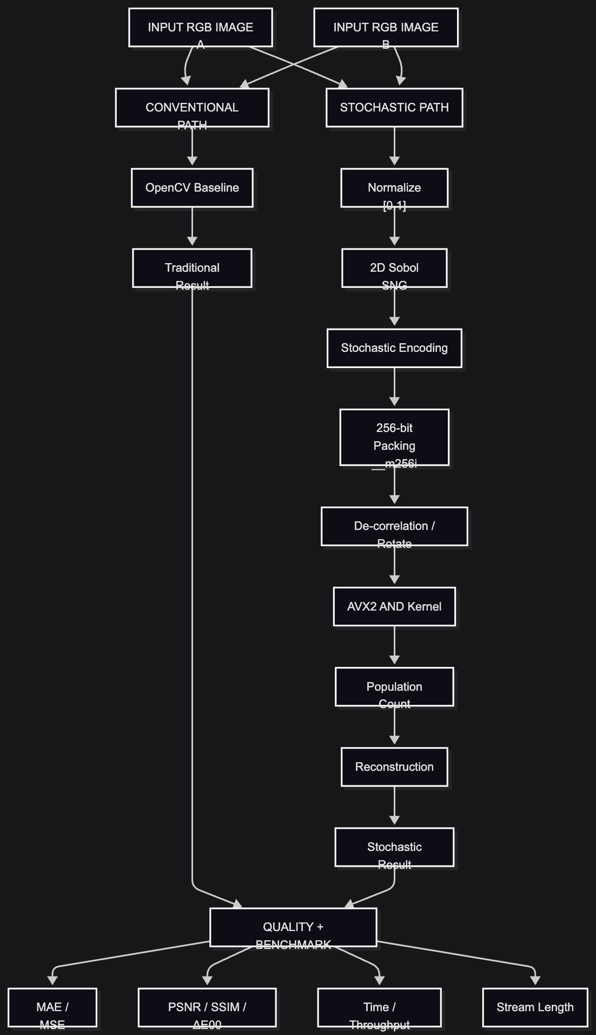

6. Correlation Is a Core Design Issue
This is a major change from the first implementation plan. The IEEE paper states that an AND gate performs stochastic multiplication when the input bit-streams are independent. With high positive correlation, the same AND gate can instead behave like a minimum operation. Therefore, simply generating two related Sobol streams is not enough.
The updated design therefore treats de-correlation as an explicit module. The additional project resource proposes circular bit rotations between processing stages and the use of orthogonal Sobol dimensions for channel separation.
- Control: no rotation.
- Candidate: fixed non-zero circular rotation.
- Sweep: several rotation offsets.
- Measure stream correlation and multiplication error for each configuration.
- Select the configuration that provides the required accuracy without unnecessary processing.

7. RGB Processing
The final benchmark should use RGB rather than only grayscale. For every pixel:
Rout = RA × RB
Gout = GA × GB
Bout = BA × BB
Each channel is normalized to [0,1], processed independently through the stochastic multiplier, then converted back to [0,255].
Grayscale remains useful as a debugging stage because it isolates the mathematical kernel, but RGB is the final application target.

8. Stream Length
The additional resource specifies N ∈ {128, 256, 1024}. These become the primary experimental values.
- N=128: low-sample/low-latency experiment.
- N=256: primary baseline and natural match for one 256-bit AVX2 vector.
- N=1024: higher-accuracy experiment.
The IEEE paper also reports that Sobol accuracy can decline sharply when stream length is reduced, so stream length must be measured rather than treated as a fixed constant.

9. AVX2 Vector Architecture
The proposed optimized implementation packs 256 stochastic bits into __m256i registers. The multiplication kernel is:
__m256i result = _mm256_and_si256(streamA, streamB)
This performs 256 independent bitwise AND operations in one vector instruction.
Supporting operations may include:
_mm256_loadu_si256
_mm256_storeu_si256
_mm256_and_si256
_mm256_or_si256
_mm256_xor_si256
_mm256_andnot_si256
_mm256_setzero_si256
The statement '256 operations per clock cycle' should not be treated as a measured CPU-performance claim. It describes the vector width; actual throughput depends on the CPU microarchitecture, compiler, memory system, and surrounding instructions.

10. Popcount and Reconstruction
After the AND operation, count the number of ones and decode:
normalized_result = total_ones / N
output_pixel = round(normalized_result × 255)
The implementation should use hardware population-count support where available and provide a fallback when the required instruction is unavailable. The benchmark should record which path was used.

11. Sobol Generator
- Maintain the current Sobol index/state.
- Maintain direction numbers for the selected precision.
- Generate X and Y coordinates in [0,1).
- Keep generation deterministic and reproducible.
- Validate the first generated points against a trusted reference.
- Benchmark Sobol generation separately from the image kernel.
The exact direction numbers and indexing convention remain implementation details that must be fixed and validated before the final benchmark.

12. Data Representation
- Image pixel: uint8_t, range 0–255.
- Reference normalized value: float/double, range 0–1.
- Hardware-oriented fixed-point value: uint16_t.
- Sobol state: uint32_t or uint64_t.
- Packed stochastic stream: __m256i, 256 bits.
The original notes mention 16-bit inputs; the new implementation resource uses 8-bit image pixels. These are different layers and should not be conflated.

13. Technology Stack
Component | Technology
Language | C++17
Compiler | GCC 11+ or Clang 13+
Build | CMake 3.18+
Image processing | OpenCV
CPU SIMD | AVX2 / <immintrin.h>
Vector register | __m256i, 256 bits
Timing | std::chrono
Analysis | Python 3.10+
Quality metrics | scikit-image
Color metric | colour-science / ΔE00
Plots | matplotlib
Environment | Ubuntu 22.04 LTS or WSL2
Reference utilities | Boost Sobol/random where useful
Version control | Git

14. C++ Project Structure
project/
├── CMakeLists.txt
├── include/
│ ├── sobol_generator.hpp
│ ├── stochastic_encoder.hpp
│ ├── stochastic_multiplier.hpp
│ ├── avx2_kernels.hpp
│ ├── traditional_multiplier.hpp
│ ├── metrics.hpp
│ └── benchmark.hpp
├── src/
│ ├── sobol_generator.cpp
│ ├── stochastic_encoder.cpp
│ ├── stochastic_multiplier.cpp
│ ├── avx2_kernels.cpp
│ ├── traditional_multiplier.cpp
│ ├── metrics.cpp
│ └── benchmark.cpp
├── tests/
│ ├── test_sobol.cpp
│ ├── test_scalar_multiplier.cpp
│ ├── test_avx2_kernel.cpp
│ └── test_correlation.cpp
├── python/
│ ├── analyze_metrics.py
│ ├── plot_tradeoffs.py
│ └── profile_images.py
├── images/
├── results/
└── main.cpp

15. Hardware-Oriented Registers
Register/Storage | Width | Purpose
REG_A / REG_B | 16/32-bit | Input/fixed-point values
SOBOL_INDEX | 32-bit | Current sequence index
SOBOL_X / SOBOL_Y | 32/64-bit | Current Sobol state
DIR_X / DIR_Y | ROM | Sobol direction numbers
BIT_COUNTER | log2(N) | Stream position
ONES_COUNT | log2(N)+1 | Output one count
ROTATE_STATE | implementation-defined | De-correlation state
OUTPUT | 16-bit | Decoded result

16. Hardware-Oriented FSM
IDLE
↓
LOAD_INPUT
↓
NORMALIZE / FIXED_POINT
↓
INIT_SOBOL
↓
GENERATE_SOBOL
↓
ENCODE_A / ENCODE_B
↓
PACK_256
↓
DE-CORRELATE
↓
AND_OPERATION
↓
POPCOUNT
↓
ACCUMULATE
↓
CHECK_N
├── more bits → GENERATE_SOBOL
└── complete → DECODE → OUTPUT → IDLE

17. Benchmark Strategy
- Use the same input images for both methods.
- Exclude image loading and disk writing from the core-kernel timing.
- Warm up before measurement.
- Run multiple repetitions.
- Measure average, minimum, maximum, and standard deviation.
- Measure Sobol generation separately.
- Measure encoding/packing separately.
- Measure AVX2 AND/de-correlation/popcount separately.
- Measure the complete stochastic pipeline.
- Record CPU model, compiler, flags, OS, OpenCV version, and AVX2 support.
The key performance question is not whether an AND instruction is cheaper than a floating-point multiply in isolation. It is whether the complete vectorized stochastic architecture provides a useful performance/accuracy trade-off.

18. Dataset and Evaluation
The additional resource identifies Kodak and McMaster datasets. The program should support both individual images and batch processing over dataset directories.
- Initial debugging: synthetic RGB images.
- Kernel validation: known pixel-value test cases.
- Primary benchmark: Kodak.
- Secondary benchmark: McMaster.
- Optional extension: user-supplied images.

19. Quality Metrics
Metric | Purpose | Tool
MAE | Average absolute pixel error | C++ / Python
MSE | Average squared pixel error | C++ / Python
PSNR | Reconstruction fidelity | scikit-image
SSIM | Structural similarity | scikit-image
ΔE00 | Perceptual color difference | colour-science

20. Proposed Targets
The additional design document proposes, for N=256:
• SSIM ≥ 0.990.
• ΔE00 < 0.85.
• >98% gate-count savings versus a binary array multiplier as a hardware-oriented target.
• 256-bit AVX2 vector operation width.
These are targets from the supplied resource, not results of our implementation. They must be independently measured before being claimed.

21. Literature-Grounded Decisions
- The IEEE paper confirms unipolar stochastic representation over [0,1].
- It states that AND performs multiplication when the input streams are independent.
- It shows that correlation directly affects stochastic arithmetic.
- It evaluates Sobol, VDC, and LFSR sequence sources.
- It reports improved accuracy from Sobol in its division experiments.
- It shows that stream length affects accuracy.
- It validates stochastic computing with an image-processing case study.
The IEEE paper is specifically about stochastic division, not this exact image-multiplication project. Its role here is methodological: it supports the stochastic representation, correlation analysis, and low-discrepancy sequence approach. It should not be used as direct evidence of our final multiplication performance.

22. Sobol vs VDC: Future Extension
The paper reports that VDC can be much lighter and faster in hardware than Sobol in the configurations it studied, while retaining strong accuracy. This is useful for future design-space exploration, but the current project remains centered on 2D Sobol because that is the specified project direction.
A later extension can add VDC as a third generator and compare generator cost, accuracy, and latency.

23. Development Roadmap
- Phase 0 — Environment: Ubuntu/WSL2, GCC/Clang, CMake, OpenCV, Python, scikit-image, colour-science, AVX2 check.
- Phase 1 — Mathematical core: implement and validate 2D Sobol generation.
- Phase 2 — Scalar stochastic multiplier: verify 0.75 × 0.50 ≈ 0.375 and a matrix of known products.
- Phase 3 — Correlation study: independent/orthogonal streams, correlated control, circular rotation, error measurements.
- Phase 4 — RGB image pipeline: normalize, encode, multiply, reconstruct.
- Phase 5 — AVX2 vectorization: 256-bit packing, AND, rotation, popcount, scalar-vs-AVX2 verification.
- Phase 6 — Benchmarking: N=128/256/1024, multiple image sizes, Kodak and McMaster.
- Phase 7 — Quality analysis: MAE, MSE, PSNR, SSIM, ΔE00, difference images, quality-vs-stream-length curves.
- Phase 8 — Optimization: profile first; then improve memory layout, packing, threading, and SIMD.
- Phase 9 — Hardware mapping: registers, direction-number ROM, FSM, comparators, AND datapath, popcount, and de-correlation.

24. Experimental Matrix
Method | N | Image size | Channels | Measurements
OpenCV baseline | N/A | 256² / 512² / 1024² | RGB | Time
Sobol stochastic | 128 | same | RGB | Time + quality
Sobol stochastic | 256 | same | RGB | Time + quality
Sobol stochastic | 1024 | same | RGB | Time + quality
Sobol + de-correlation | 128/256/1024 | same | RGB | Time + quality
Correlation control | 256 | small test | 1-channel | Product error

25. Deliverables
- Validated 2D Sobol sequence generator.
- Scalar stochastic multiplication reference.
- C++/OpenCV RGB stochastic image multiplier.
- AVX2-vectorized stochastic kernel.
- De-correlation module and correlation analysis.
- Conventional OpenCV baseline.
- Benchmark suite for stream length and image size.
- Python quality-analysis suite.
- Output and difference images.
- Performance/accuracy plots.
- Hardware-oriented architecture with registers and FSM.
- Final comparison of conventional and stochastic approaches.

26. Final Research Question
Can a 2D Sobol low-discrepancy stochastic computing architecture perform RGB image multiplication with substantially simpler multiplication logic while maintaining acceptable image quality and achieving a useful computation/performance trade-off on a vectorized C++ implementation?
The evaluation therefore has three dimensions:
1. Arithmetic correctness — does stochastic multiplication approximate A × B?
2. Image quality — is the stochastic image sufficiently close to the conventional result?
3. Performance — does the vectorized stochastic architecture justify Sobol generation, encoding, de-correlation, and reconstruction overhead?

27. Source Boundaries
Source-derived additions from P3-2.pdf include RGB normalization, 2D Sobol stochastic generation, N={128,256,1024}, __m256i packing, AVX2 bitwise kernels, circular rotation/de-correlation, population-count reconstruction, Python quality analysis, Kodak/McMaster datasets, and the stated SSIM/ΔE00/gate-reduction targets.
The original project notes provide the 2D Sobol generator concept, 16-bit representation, and the 0.75 × 0.50 example.
The 2024 IEEE paper supports unipolar stochastic representation, the AND multiplication condition for independent streams, the importance of correlation, low-discrepancy sequences, and stream-length effects.
Exact Sobol direction numbers, exact rotation offsets, fixed-point scaling, CPU instruction availability, and final hardware register widths remain implementation decisions and must be validated during development.

